6.
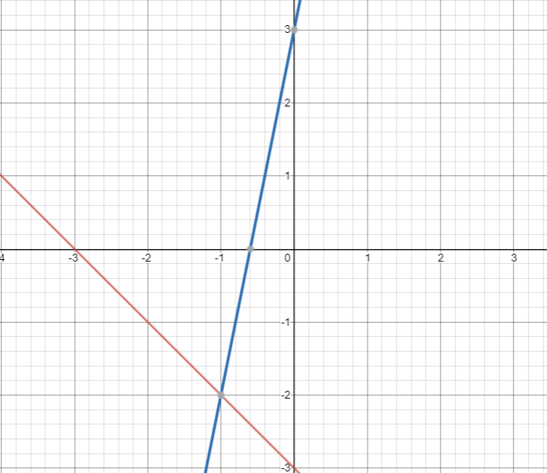

7.
m =-1, b = 3
m =4, b=-2

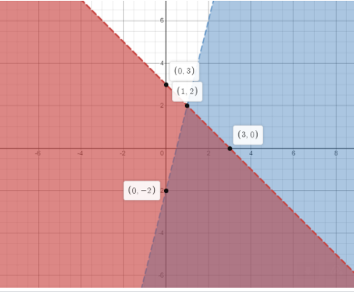

8.
m = -3, b = -1
m = -1, b = -3

